C:\Users\admininstall\AppData\Local\Microsoft\Windows\INetCache\Content.Word\arrow2.pngC:\Users\admininstall\AppData\Local\Microsoft\Windows\INetCache\Content.Word\arrow2.pngC:\Users\admininstall\AppData\Local\Microsoft\Windows\INetCache\Content.Word\arrow2.pngC:\Users\admininstall\AppData\Local\Microsoft\Windows\INetCache\Content.Word\arrow2.pngC:\Users\admininstall\AppData\Local\Microsoft\Windows\INetCache\Content.Word\arrow2.png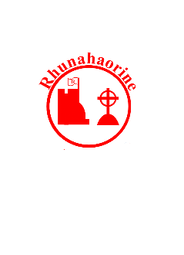

*CB June 2023 achievements in yellow January 2024*

**Kilmartin & Campbeltown Museums** ongoing

**Pupils setting and recording progress** ongoing

**Apps for learning** ongoing

**Classroom Assistant for 1:1 support**

**Staff training with ‘Wildthings’ Outdoor Learning**

**Promote and use UNCRC**



**Rights Respecting School Committee**

**Research standing stones**

**Digital Learning**

**Memberships & iPads**

**Live Argyll - Aqualibrium Swimming Active Schools Silver Award**

**Curiosity Clubs – Yoga, Virtual Games**

**Achieved Bronze creditation in Rights Respecting School**

**Children linking learning to rights**

**Rights Respecting School Committee**

**Partnership for Health and Wellbeing**

**Research real jobs**

**Growth On Our Doorstep project**

**Extend partnerships with local businesses**

**Enhance curriculum delivery in line with the Developing the Young Workforce policy**

**Develop creativity and skills for life through ‘Ancient Farmers in Argyll’ Museum link project**

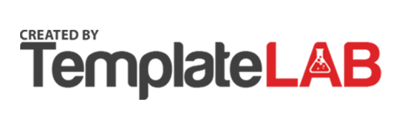

**Embed RRS and aim for Silver**

**Increase knowledge of locality and culture**

*Our strategic plan for wellbeing continues to be Outdoor Learning when and wherever possible*

**Ensuring wellbeing, equality and inclusion through involvement in RRS**

**Ensuring wellbeing, equality and inclusion through involvement in RRS**

**Maths & Rhyme Bags**

**Maths & Numeracy tbd**

**Digital Learning Memberships & iPads**

**PEF (Pupil Equity Funding)**

**Digital learning in numeracy & maths**

**Outdoor Learning**

**Classroom Assistant for 1:1 reading**

**PEF (Pupil Equity Funding)**

**School Improvement Plan 2023/24**

**“This session we will …”**

**Standards and Quality 2022/23**

**“Last Session we did …”**

